**Pyspark Assignment**

**Crime Data Analysis**

**Dataset: crime_incidents_2013.csv**

1. **How many offenses were there in 2013?**

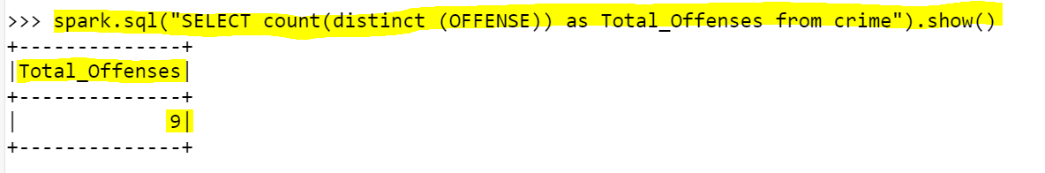

1. **How many crimes were committed in each offense?**

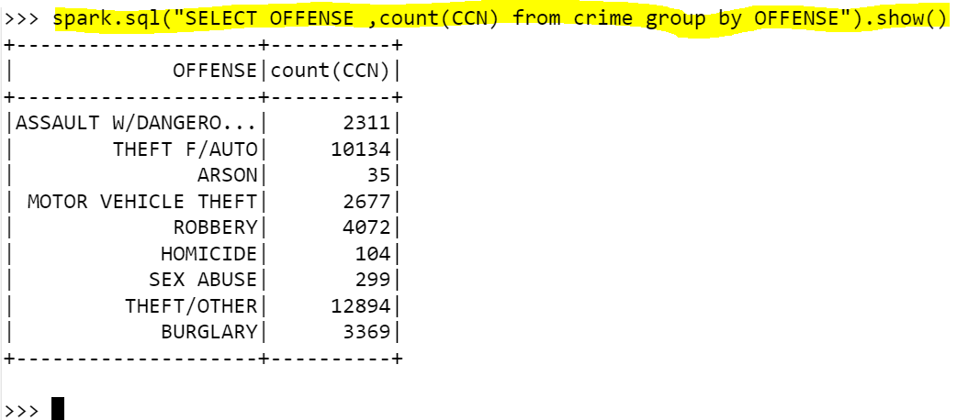

1. **How many different methods were used (And their count) in offense “Homicide”.**

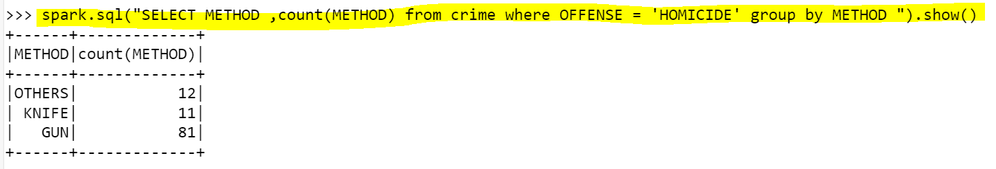

1. **Which shift had the maximum crime?**

